**KIBUUKA MIXED PRIMARY SCHOOL – NANSANA**

**P.1 ENTRY INTERVIEW 2023**

**Name: ……………………………………………………………………….**

**Class: ……………………………………… Date: ………………………..**

**ENGLISH**

1. **Sound with actions.**

**ck s fl p ch**

1. **Complete these sentences.**

It is a ____________________.



Here is a __________________.

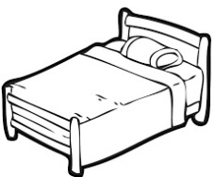

It is a _____________________.

1. **Read and draw.**

I can see a rat.

I can see a bird.

**MATHEMATICS**

1. **Name these shapes.**

_____________ _____________

______________

(zig zag rectangle circle)

1. **Add these numbers.**

5 + 2 = _____ 6 + 7 = _____

**3 + 3 = ____ 8 + 2 = ______**

1. **Count and write.**

= _____

= ________

= ­­­______

**LITERACY 1A**

1. **Read and draw the God’s creation.**

|  |  |
| --- | --- |
|  |  |
| moon | sun |

1. **Match and draw the dangerous things.**

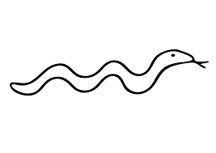 broken bottle ____________

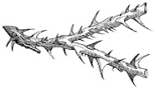

snake ____________

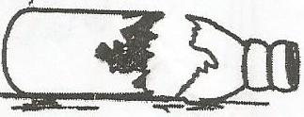

thorns ____________

**LITERACY 1B**

1. **Match and draw these people.**

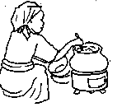

nurse cook _____________

policeman cleaner _____________

teacher driver ____________

cook nurse ____________

cleaner policeman ____________

driver teacher ____________

***\*\*\*Good Luck\*\*\****